MEMORANDUM

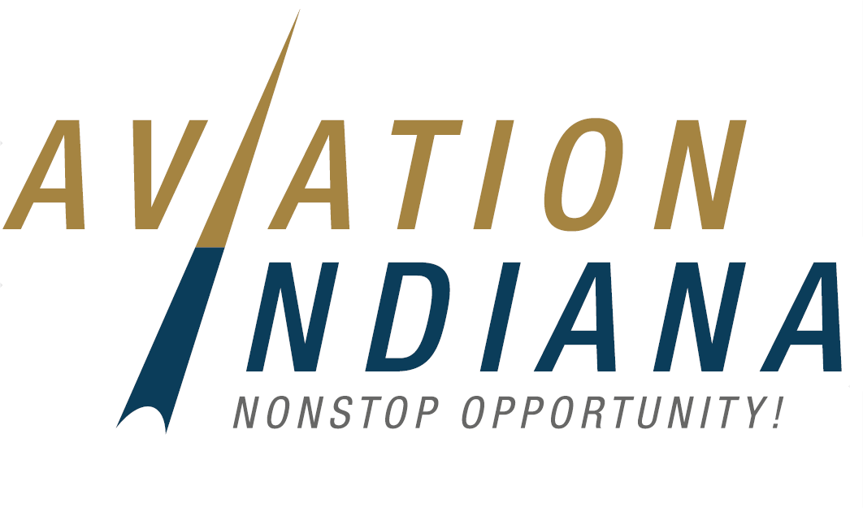
To: Aviation Indiana Membership
From: Sean Smith, Sponsorship Chair
Date: August 17, 2023
RE: 2023 Sponsorship Drive

Aviation Indiana (AI) is looking forward to the 2023 Annual Conference that will be held at the Grand Wayne Convention Center on October 10 – 12th. The Conference Committee is looking to highlight Northeast Indiana and is excited about this year’s agenda that includes a half- day session dedicated to FBO issues.

Aviation Indiana had a very successful 2023 legislative session that created an additional ongoing funding stream for aviation projects as well as a large state investment in airport projects. AI continues to be the voice of aviation in Indiana and our voices were heard by our legislative leaders. If you are interested, please let us know and we will send you a list of our Legislative Accomplishments over the years. However, there is still much work to be done. We must continue to get the word out about the important role our airports play in building our economy and continue to fight for dedicated funding for aviation. If we do not tell our aviation story, who will?

We are more than just a lobbying organization - we are the leaders in promoting Indiana aviation. The conference is a great time to network and share ideas to solve issues. We are more than just airports – we also work on issues that help FBO’s, pilots, businesses who use aviation to reach their customers, and aviation manufacturers. Aviation Indiana will continue to work with INDOT and the FAA to improve our airports and continue to provide airport users the opportunity to reach their customers in the most efficient manner.

We are asking you to reach out to potential sponsors. Please note that a written letter or an email cannot replace a strong relationship and a personal phone call. We encourage you to follow up every non-verbal contact with personal conversation to discuss how their contributions are used and can benefit them as well as aviation as a whole. Potential sponsors can include any vendor you do business with at your airport, including suppliers for your terminal building needs, construction contractors, chemical suppliers that help maintain your turf areas and control wildlife, equipment and parts manufacturers, etc. If you have done business with someone at your airport and maintain a good personal relationship, please consider reaching out. Who knows, perhaps your passion for Aviation Indiana will “propel” them into membership or participation!

To make things easier, we are now accepting sponsorships online. Sponsorships may be made at: 2023 Sponsorships | Aviation Indiana
Suggestions & Procedures

Make contacts and have pledges as soon as possible. Some of the top solicitors initiate their task by sending out letters/emails to potential sponsors in August and explaining the specifics of the Sponsorship Drive. Many pledges and checks come in with that effort alone. They then follow up with a phone call in a couple of weeks to vendors they have not heard from. This method is very effective and eliminates some of the discomforts of cold calling! We have included a draft solicitation that can be cut and pasted as a sample for you. A thank you letter from Aviation Indiana will also be mailed to each contributor after the conference.

Once you have received a pledge commitment, complete the attached 2023 “Aviation Indiana Sponsorship Drive” form (and Sponsorship Opportunity form, if applicable). These forms may be emailed to Bart at bartgiesler@gmail.com. They can mail a check directly to:

Aviation Indiana
135 N. Pennsylvania Street, Suite 1175
Indianapolis, IN 46204.

In order to make the process easier, we are now offering for sponsors to sign up online. Information can be found at aviationindiana.com

It is important to have our pledges completed by September 22 so that we can properly acknowledge our sponsors. Questions can also be directed to Sean Smith - ssmith@cmtengr.com or Bart Giesler at bartgiesler@gmail.com or (317) 916-4184.

All sponsors will be acknowledged during the conference and in conference newsletters and on the website. Please see the attached Sponsorship Opportunities page.

